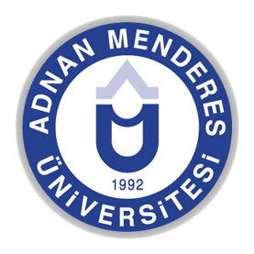
ADNAN MENDERES UNIVERSITY
International Symposium "Reminiscences" from the Ottoman Empire to the Turkish Republic
(April 25-27, 2018/AYDIN)

I hereby confirm that;
The paper titled ………………………………………………………….. that I would like submit to the International Symposium "Reminiscences" from the Ottoman Empire to the Turkish Republic, on April 25-27, 2018, is a product of a genuine research and not presented in any scientific meeting and not published before, and is not included, partly or totally, in any dissertation, book or article; and presentation and text is not in breach of laws of Intellectual and Industrial Property.

…../…../2018
SIGNATURE

Participant’s

Name and Surname: ……………………………………………………………………………
Title: ……………………………………………………………………………………………
Institution: ……………………………………………………………………………………...

